Chapter One
MA Thesis Structure

An MA thesis is made up of a title page, a table of contents, an introduction, several chapters, a conclusion, references, a summary in Polish (Streszczenie), and – optionally – appendices I, II, etc. Apart from enumeration, each chapter must have a title. The specific structure and the contents, included in its specific parts, must be agreed upon together with the MA supervisor
At least 10 days before the planned final exam, the MA must be handed in at the Dean’s Office. The MA thesis should be printed in three copies: one for the supervisor, one for the reviewer, and one for the Dean’s Office (print format—see point 1. under text style). Furthermore, the exact copy in digital format (.pdf) should be transferred to a digital drive in the APD system. A written declaration is necessary, which states that the work has been written independently, and that the printed versions and digital version are identical.

Chapter Two
Recommendations concerning the writing style of the computer text

1. The writing style
The complete MA, in 3 copies, should fit within the boundaries of 60 to 80 computer-printed pages, to be printed one-sided for the supervisor and reviewer, and two-sided for the archives. The recommended font is Times New Roman, size 12, for the main text, the bibliography and the summary, and size 10 for secondary parts: quotes, examples of analysed material, and appendices). The spacing should be 1.5 for the main text, and 1 for secondary parts. All margins (left, right, top and bottom) should be 2.5 cm of the visible page. For indented text (the start of paragraphs, block quotes, and bibliographical notes), the left margin has a further 1.25 cm indentation added. Each chapter ought to start on a new page. The text ought to be put in a block (justified) with no additional spacing between paragraphs; and words should not be broken off at the end of lines, and orphan and widow control should be enabled.

1.1. Main headings
The headings of the introduction, the chapters, the conclusion, the references section, the summary, and appendices must be centred, and written in the bold typeface of Times New Roman, size 14. The distance from the heading to the first line below must be two empty spaces. Headings do not take full stops.
[Example] Chapter Three
Recommendations concerning the MA thesis written at the NCU English Philology Department

1. Methodological aspects of an MA thesis
An MA should …
[End of example]

1.1. Headings
The headings of individual parts of chapters are positioned directly above the main text, and separated from the text above by one empty line. Bold face Times New Roman, size 12, is used for these subheadings, which are not indented (see above). Size 12 of Times New Roman, not in bold but in italics, is advised when the need exists for sub-subheadings or even further subdivisions. The situation where two or more headings follow each other without regular text in between needs to be avoided.

[Example]
2. Methodological aspects of an MA thesis
The MA should …

2.1. The overall character of an MA thesis
The MA should never …

2.1.1. The style of an MA thesis
The MA should …
[End of example]

2.1.2. The numbering of pages and the practice of indentation
Page numbers appear at the bottom of each printed page, centred. Page 1 is the first page of the introduction. Please note that every section’s first paragraph (i.e. under each heading or subheading) does not require indentation.
However, the next paragraph and each paragraph after that (for exceptions see section 3.2. Long quotes) should be properly indented (1.25 cm for the first line).

[Example]
2.2. The overall character of an MA thesis
An MA should never … (first paragraph).
In the first chapter there ought to be … (second paragraph).
[End of example]

With bibliographical notes, each further line of one entry is indented in relation to the first line of that entry (hanging indentation):

Tomasello, Michael. 2003. Constructing a Language: A Usage-based Theory of Language Acquisition. Cambridge, MA: Harvard University Press.

2.3. The title page and the style of the table of contents
It is advised to use the template located online, and which correctly allocates the required layout to these two sections.

3. How to write quotes
Please bear in mind that all of the following regulations concerning listing sources, both in the main text as well as in the References section, serve as basic guidelines and will be modified by the supervisor if more information is necessary. The supervisor determines the appropriate level of detail in citing sources.
3.1. Short quotes
Short quotes (shorter than 40 words) should be located within the text and enclosed by double quotation marks. Single quotation marks are for quotes within quotes. Rounded (curly) and not straight quotation marks must be used. In parentheses, the source of the quote must be written immediately after the closing quotation marks, but still before the full stop, or other main punctuation character that closes off the sentence or clause. [Example] “We discard the so called ‘modularity view’ attributed to Chomsky” (Lakoff 1987: 208). When two authors are the source, both must be mentioned, as in: (Lakoff and Johnson 1980: 122), and when more than two authors are used, the abbreviation “et al.” must follow the first name: (Varela et al. 1983: 156–157). If the author(s) wrote more than one book in the same year, alphabetically-ordered small letters will enable source identification, for example: (Lakoff 1976a: 121) (Lakoff 1976b: 82).

3.2. Long quotes
Long quotes are meant to draw attention to the quoted material. Poetry, dialogues and letter fragments, as well as prose excerpts longer than 40 words must take the form of a block quotation:

Longer quotes must be placed in a text block with 1.25 cm indentation on both sides, in font Times New Roman, size 10, with a line spacing of 1. One empty line forms the distance between the block quotation and the text above and below. Sources are to be mentioned as outlined in 3.1. The bracket should fall after the last punctuation mark of the quote/sentence [Example where “Lakoff” is the beginning of a paragraph and “metaphor” the end] It should be noted that [...] is the essence of the conceptual theory of metaphor. (Lakoff 1987: 208) [End of example]

The paragraph after the block quote has no indentation. Please bear in mind that a block quote should be used purposefully, clearly introduced and followed by a comment.

3.2.1. Poetry and song lyrics
Treat a single line of poetry or lyrics as any other type of in-text citation, i.e. include the line within double quotation marks [Example] “Thou still unravish’d bride of quietness” (“Ode on a Grecian Urn,” 1820) [End of example]. For two lines and more, format the quotation like a block quote. Preserve the original punctuation.

Thou still unravish’d bride of quietness,
Thou foster-child of silence and slow time,
Sylvan historian, who canst thus express (“Ode on a Grecian Urn,” 1820)

Provide the title of the song and the copyright year for in-text citations of lyrics. [Example] “You say you got a real solution” (“Revolution 1,” 1968) [End of example].

3.3. Foreign quotes
Specific terms and phrases which will not be translated (e.g. Schadenfreude or omoiyari) when introduced and explained for the first time, should be enclosed by double quotation marks and in italics; after that, quotation marks are no longer necessary. All foreign quotes used for the purpose of argumentation or exemplification must be translated into the language of the dissertation. If the translation was done by the MA author, this fact must be signalled, and the original version provided either in the main text itself, or in a footnote, depending on the length. [Example] “Kononowicz promised that ‘niczego nie będzie,’ which could be roughly translated as ‘there will be nothing’ (Kononowicz 2002, my translation). However, some disagree with this phrasing.” [End of Example] Elements of a quote which are left out need to be replaced by three full stops in square brackets. Square brackets are also used to show all the words changed by the MA writer. [Example – in this quote “it” has been substituted by “metaphor”]: “One of our claims is that [metaphor] is one of the most important cognitive processes.” [End of example]

4. Mentioning sources in the text, or in the bibliography
All reference information is provided in a separate part at the end of the MA thesis, under references.
As far as quoted sources are concerned—following the rules outlined in 3.1.—in parentheses the author is first mentioned, followed by the year of publishing and the precise page number(s) of the quote used: [Example] (Lakoff 1987: 208). The name of the author can be omitted if they are identified in the text and no other author is mentioned in-between. [Example] Lakoff discusses ... (1987: 208). The reference must fit in one continuous sentence. Supplying the page numbers is done in full, e.g. 43–45 or 143–145 (and not 43–5 or 143–45).
With translation, the information of the original edition and title will be mentioned in the bibliography. If several translations of the works of a given author are analysed, the name of the translator must also be provided in the main text in references, so that the translations can be easily distinguished [Example] (Jones trans. Smith 2000: 122) as opposed to (Jones trans. Brown 2001: 44) [End of Example].
When the surname of an author is summoned in the body of the text, there is no need to give their first name every time after the first time they are mentioned; however, when the first name is given (for the first time), it should not be abbreviated but its full form should be quoted (e.g. George Lakoff).
When the cited author quotes some material themselves, brackets are used for the information on both sources [Example] (Wittgenstein 1953: 122 in Lakoff 1987: 208).
The reference information for films, TV series episodes and games (digital, mobile, board etc.) is also provided in parentheses, with title first, followed by the release year. [Example] (Journey, 2012). [End of example]
In the case of Internet users’ opinions, the username must be provided in regular script, and the title of the blog post or thread must be supplied in italics. [Example] In the thread The Turn of the Screw: Henry James’s Gothic ghost story that’s still scaring us over 100 years later the user battlefax notes that “The book was purposely written to be ambiguous, and skirt the boundary between (the qualities of) fiction and non-fiction” (www.reddit.com).
[End of example].
For Internet sources, the year in which the content was posted follows the author’s surname or username (if it is known, in the case of online articles, blog posts etc.), or the web address is written on its own if no author can be identified (e.g. wikis). The web address is given without its root (i.e. without http://), it is shortened to its domain name and given in parentheses, for example: (en.wikipedia.org). If the author’s name is available, the reference takes the form: (Krugman 2017). With more entries for the same year, the following reference form should be used: (Krugman 2017a), (Krugman 2017b) etc. To prevent these addresses from being printed in blue and being underlined (hyperlinks), the hyperlinks need to be removed before printing. Full information concerning the internet source must be provided in the appropriate section of the references.
When citing information given in a lecture or seminar, include in parentheses the lecturer’s name, year of delivery and information concerning the type of class: [Example] (Patter 2016, in a lecture). For details concerning the creation of a complete reference entry for lectures/seminars, see section 5.1.6 below.
Citing authors ought to be done in full; without abbreviations such as “op. cit.,” “loc. cit.,” “ibid.” “f.,” or “ff.” However, some option can be the use of common abbreviations: “ca” for “circa” (with dates), “e.g.” = “exempli gratia” – ‘for example, “et al.” = “et alii” /masc. pl./, et alia” /neut. pl./, “et alibi,” – ‘and others’, ‘and elsewhere, “etc.” = “et cetera,” “i.e.” = “id est” – ‘that is’, ‘in other words’, or, finally: “inter alia” – ‘among others’.

5. Tables, diagrams, drawings, illustrations and examples
Tables, diagrams, drawings, illustrations and examples must be enumerated and titled. Enumeration is continuous throughout the MA thesis. If they come from other works, their source should be mentioned in brackets after the title. All drawings and examples are numbered continuously throughout the work.

5.1. Tables, diagrams, drawings and illustrations
Table titles are given at the top, and diagrams, drawings and illustrations are titled below. For all citations Times New Roman, size 10 and a line space of 1 are used. Tables, diagrams, drawings, illustrations and examples should be centred on the page, similar to their names and citations.
[Examples:]

Table 1. Sample table; the text within the table is of 10 pt size, the line width is 0.50 pt.
 | Column 1 | Column 2 | Column 3
Row 1 | entry | entry | entry
Row 2 | entry | entry | Entry
Row 3 | entry | entry | Entry

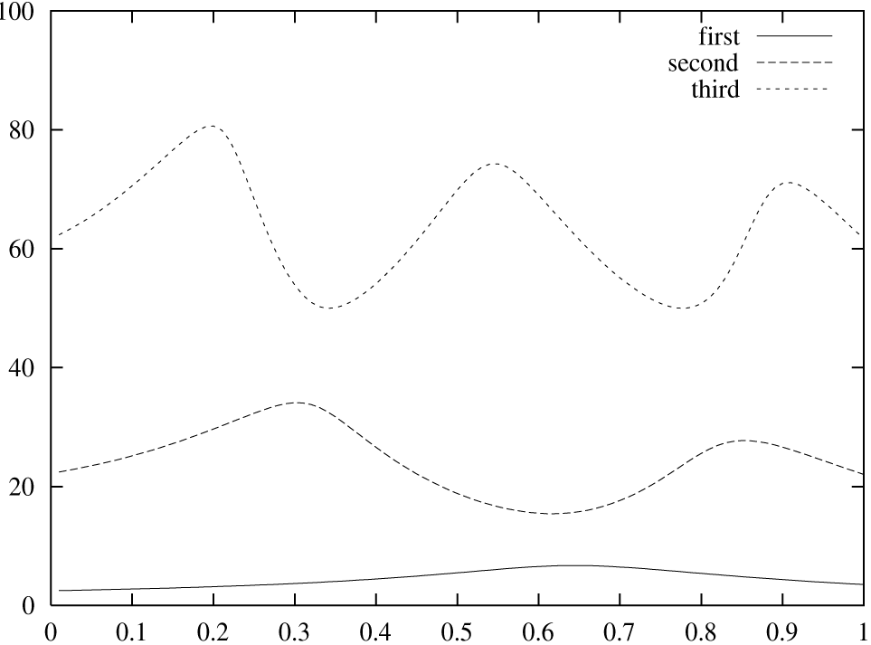
Figure 1. An example graph. All labels are legible.

5.2. Language examples
Language examples must be numbered; the numbers in brackets. For text examples an indentation of 1.25 cm is used, and the font Times New Roman, size 12 plain. Use continuous numbering throughout the thesis.
[1] The cat is on the mat.

5.2.1. Translations
Examples of translations must be numbered in the same fashion language examples are; letters should accompany numbers in order to demonstrate that the first example is a piece of the source text and the second of the target text.
[1a] Nie będzie niczego.
[1b] There will be nothing.

5.2.2. Metalanguage
Whenever a term is mentioned for the first time, it ought to be written within quotation marks. This is not required for any subsequent mention of the term.
[Example]
The term “lexical entrainment” refers to the situation when speakers adopt the referring terms of their interlocutors. As such, lexical entrainment plays a vital role in developing conceptual pacts in conversation.
[End of example]

6. The bibliography
The bibliography is located in the MA part called References (with the heading formatted like any other main heading). Here only those works are specified which are dealt with in the MA, relate to its topic and are quoted from or paraphrased. All these works must be given separate entries, i.e. every time mentioning the author(s) and publisher(s). The order is alphabetical according to the author’s surname, and with team efforts, according to the first-mentioned author in the work. Apart from conjunctions and prepositions, all words ought to be capitalised. Publishers, magazines and conferences should not be abbreviated. “et al.” cannot be used as the start of an entry, and must in fact altogether be replaced by full mention of all authors and/or publishers. The original, untranslated titles of sources are alphabetically ordered.

6.1. Examples of bibliographical notes
The book titles are written in italics without quotation marks. Article titles, as well as Forewords, Afterwords and Introductions to books, individual poems, songs and short stories, meanwhile, take regular script, with two rounded quotation marks on each side. Titles of edited volumes and poetry collections are in italics, without quotation marks.

6.1.1. Books in References
One author:
Hall, Edward T. 1966. The Hidden Dimension. New York: Anchor Books.

Two authors:
Lakoff, George and Mark Johnson. 1980. Metaphors We Live by. Chicago-London: University of Chicago Press.

Three or more authors:
Passau, George, John Nemezis, and Frank Donn. 1999. Ethnomethodology. Oxford: Oxford University Press.

Translation:
Miyabe, Miyuki. 2012. Apparitions: Ghosts of Old Edo, trans. Daniel Huddleston. San Francisco: VIZ Media.

One editor:
Haight, Gordon (ed.) 1987. The George Eliot Letters. New Haven-London: Yale University Press.

Two or more editors:
Gumperz, John and Dell Hymes (eds.) 1972. Directions in Sociolinguistics. New York: Holt, Reinhart & Winston.

6.1.2. Articles in References
Here the page numbers of the article within the magazine must be mentioned, and volume before issue:

Sacks, Harvey, Emmanuel Schlegoff, and Gail Jefferson. 1974. “A Simplest Systematics for the Organization of Turn-taking in Conversation,” Language 50 (4), 696–735.

In cases other than magazines, the page numbers of the article within a larger work must also be mentioned:
Garfinkel, Harold. 1972. “Remarks on Ethnomethodology,” in John J. Gumperz and Dell Hymes (eds.) Directions in Sociolinguistics, 287–302.

NOTE: Abbreviated information about a work with more authors must be given in a separate bibliographical note.

Gumperz, John and Dell Hymes (eds.) 1972. Directions in Sociolinguistics. New York: Holt, Reinhart & Winston.

6.1.3. Internet sources in References
Internet references take the name of the author(s), the full internet address without its root, and the date of access (DOA):
Doyle, Rodger. “Female Illiteracy Worldwide,” www.sciam.com/0597issue/05975.html,
DOA April 5, 2002.
Or:
Doyle, Rodger. www.sciam.com/0597issue/05975.html, DOA April 5, 2002.

If Internet authors cannot be traced, a separate section under References must be made: Internet sources (Times New Roman, size 12 in bold script, left-aligned), under which the web page address is given alphabetically. [Example]

Internet sources
www.socsci.kun.nl/ped/whp/histeduc/locke, DOA April 5, 2002.
www.cas.usf.edu/english/walter/mla.html. DOA April 5, 2002.

6.1.4. Consulted dictionaries
For dictionaries and encyclopaedias used, there is a separate section, starting with Dictionaries and encyclopaedias (Times New Roman, size 12 in bold), must be used, after which the list of sources follows.

[Examples]
Dictionaries and encyclopaedias
Encyclopaedia Britannica. 1998. London: Britannica Press.
Longman dictionary. 1990. Harmondsworth: Longman Press.
Oxford Living Dictionaries (English). en.oxforddictionaries.com. DOA April 5, 2002.

6.1.5. Other sources cited
Films and TV series must include the title of the film or series. The title of film is followed by its release year and the director’s name, and the title of TV series is followed by the original release time and original network name:
Mama. 2013. Andy Muschietti.
MythBusters. 2003—. Discovery Channel.
Farscape. 1999–2003. Nine Network/Sci-Fi Channel.

Digital and board games must include the title of the game, year of release, and the name of the publisher:
Hellblade: Senua’s Sacrifice. 2017. Ninja Theory.
Talisman: The Magical Quest Game. 2017. Fantasy Flight Games.

Lyrics from studio albums and poems must include the author(s) of the song or of the poem. The author of the poem or of the lyrics is followed by the release date, and the date is followed by the title of the anthology or the album where the poem or the lyrics appeared. Finally, publication place and publishing house/label ought to be mentioned.

Brown, Ian and John Squire. 1989. “I wanna be adored,” on The Stone Roses. London: Silvertone.

Eliot, Thomas S. 1917. “The Love Song of J. Alfred Prufrock,” in Prufrock and Other Observations. London: The Egoist LTD.

If a piece of software is used or discussed in the work, it should be mentioned in References. Authors typically specify how their software should be cited. If not, use the following example to provide a bibliographical entry.

Sloetjes, Han and Peter Wittenburg. 2008. “Annotation by Category – ELAN and ISO DCR,” in Proceedings of the 6th International Conference on Language Resources and Evaluation (LREC 2008).

For Internet users’ opinions, the original thread or other Internet source form which the opinion comes must be included in the Internet sources sections:

The Turn of the Screw: Henry James’s Gothic Ghost Story That’s Still Scaring Us over 100 Years Later. https://www.reddit.com/r/books/comments/2fhdj6/the_turn_of_the_screw_henry_ja mess_gothic_ghost/, DOA April 5, 2016.

If the MA author uses more than two texts of the same type (films, translation versions, songs, games) a separate section with appropriate name should be created.

6.1.6. Lectures and seminars
A reference to information given in a lecture or seminar includes: the name of the lecturer, the title/subject of the lecture/seminar, type of class (lecture/seminar/...), name of institution and delivery date:
Patter, Lisa. “Gothic Literatures across the World,” lecture, KFA UMK, March 3, 2016.

7. Other technicalities
Foreign expressions, i.e. in languages other than English, are written in italics, not bold or underlined. Emphasis is given in italics. No punctuation is used to lead in short quotes—[Example] Lakoff says “The conceptual theory of metaphor ....” Longer (block) quotations require a colon—[Example] Lakoff says:
...
Alt + 0150 is advisable with lists enumerated without using Arabic numerals:
- One
- Two
- Three
Good common sense, and the supervisor, will help out in quandaries not dealt with in this document.

Footnotes are also a part of secondary text, and should only be uses for comments on or additions to the main text. The numbering of footnotes must be continuous throughout the whole work, irrespective of chapters.

